Appendix 1-Handwriting Families

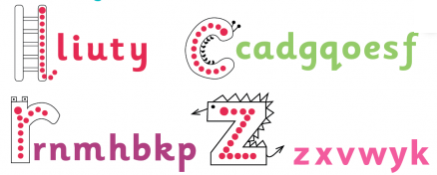

Long ladder: i, u, y, l, t, j
Curly caterpillar: c, o, a, g, d, q, e, s, f
One armed robot: r, n, m, h, b, p, k
Zig Zag: v, w, x, z



