
Y1 Autumn Homework Grid
Weekly homework: Reading, Phonics and maths
In addition, you may complete any of the following optional tasks this term and choose how you present them!
Computing | Science | Geography -UK
Can you go on a technology hunt and find different types of technology in the world around us! Remember technology is something that people have made to help them! This can be drawn, pictures taken and stuck in, present it however you like!  Challenge: Can you explain how each piece of technology helps us  EXAMPLE: A pencil is technology as it has been created by people. The pencil helps us to write down our ideas. | Create a picture to show the different seasons and how they change throughout the year.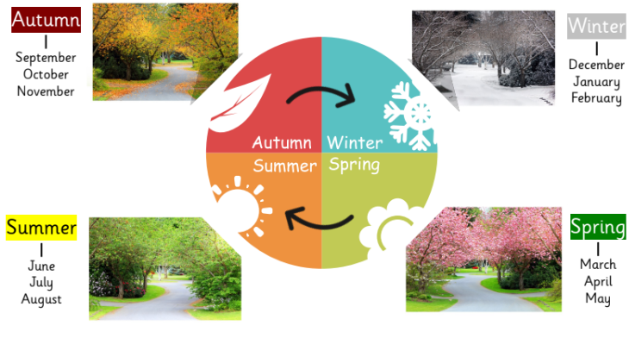 | Find and locate countries, capital cities, seas and oceans in the United Kingdom – maybe you could create your own map! 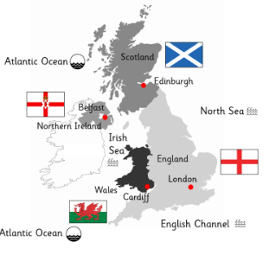
RE | Art | PE
  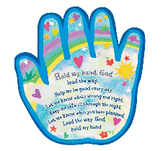  This term, we are learning about Christianity. We will explore what Christians believe God is like through parables. Can you draw a picture or make a poster of what you think God is like? | Can you collect different types of leaves and create some rubbings or prints of them using pencils, paints or crayons?  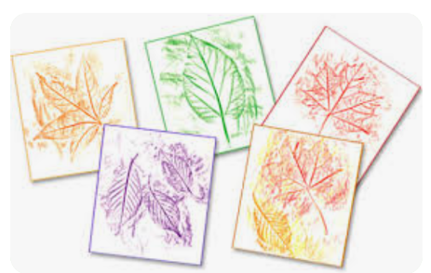  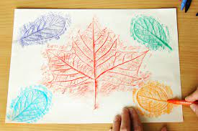 | Practice different ways of moving around to demonstrate agility. Think about what we have been learning – you can take pictures to show your movements if you wish to [put them in your book!
Geography -World
Name 7 continents and 5 oceans


