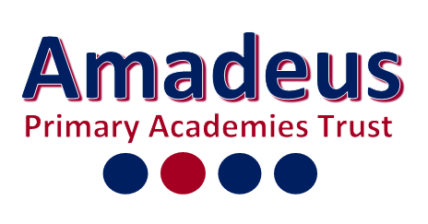 MEDIUM TERM PLAN Year: 1 Term: Autumn 1
 |  | Week Beginning: | Week Beginning: |  | Week Beginning: | Week Beginning: | Week Beginning: | Week Beginning:
Diary Dates |  | 31/8/25 | 7/9/25 | 14/9/25 | 21/9/25 | 28/9/25 | 510/25 | 12/10/25
Shared Text – End of the day |  | Goldilocks and three bears  Colour Monster  Splat the Cat | Peace at Last  Mr Large in Charge  The Gruffalo | The Day the crayons quit  Zog | The Gruffalo’s Child  Snail and The Whale  What the Ladybird Heard | The Space Tortoise  The Marvellous Moon Map | Squirrels that squabbled  The Cave Baby | The Green Ship  Mog the Forgetful Cat  The Squash and the Squeeze
Reading Text |  | Family and Me  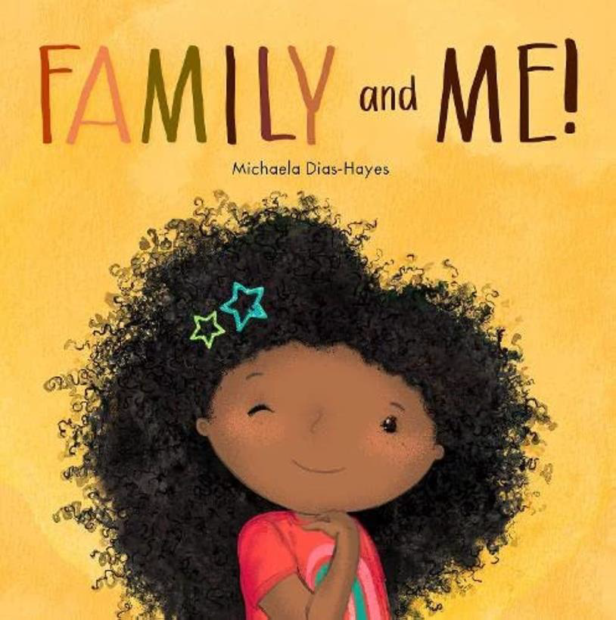 | Beegu  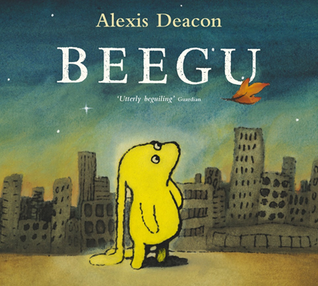 |  | Where the Wild Things Are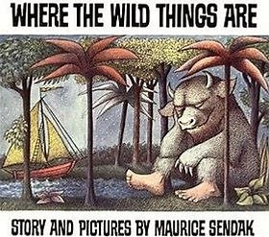 |  | The storm whale  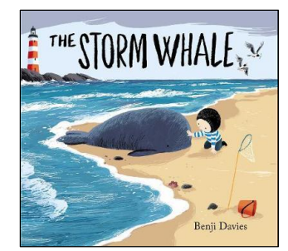
- Writing |  | All about me:  Use of capital letters and full stops | Poetry-Pattern and Rhyme | Setting Descriptions |  | Instructional writing
- Phonics and/or spelling |  | Baseline assessment | Review Week 1 | Review Week 2 | ay ou ie ea | oy ir ue aw | Review Week 3  Assessment | wh ph ew oe
Maths |  | Place value (within 10) |  |  |  |  | Addition and Subtraction
RE |  | Key Question: Who do Christians say made the world?
Science |  | SEASONS |  |  |  | PLANTS
Computing |  | Technology around us
Topic | History | - | - |  | - | - | - | -
Topic | Geography | N/A | Key Question:  What are the 7 continents  of the world?  Where are they? | Key Question:  What are the 5 oceans of the  world? Where are they? | Key Question:  Where are the 4  countries of the  United Kingdom? | Key Question:  What are the 4 capital  cities of the United  Kingdom? Where are they? | Key Question:  What seas and oceans  surround the United  Kingdom? | Consolidation
Topic | Art | Drawing block A
Topic | DT | - | - |  | - | - | - | -
PE |  | Health and Wellbeing  Team Building | Health and Wellbeing  Team Building | Health and Wellbeing  Team Building | Health and Wellbeing  Team Building | Health and Wellbeing  Team Building | Health and Wellbeing  Team Building | Health and Wellbeing  Team Building
Music |  | Ourselves | Ourselves | Ourselves | Ourselves | Number | Number | Number
PSHCE  (Wellbeing, P4C, Circle time, Cultural capital) |  | Class Rules | British values | NEW CURRICULUM

