
Y4 Homework Grid: Autumn
Weekly homework: Reading, maths, spelling sheet and TTRS online.
In addition, you may complete any of the following optional tasks this term and choose how you present them!

Art: drawing | Art-drawing | Geography: Rivers
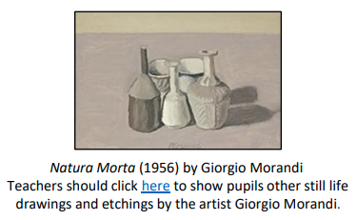  We will be creating continuous line drawing of objects. Place a pencil on the page, draw the object you are looking at without looking at your paper and do not take your pencil off of the page. | Choose 3 items in your home to sketch. Can you shade them to show dark and light tones in the negative space? | 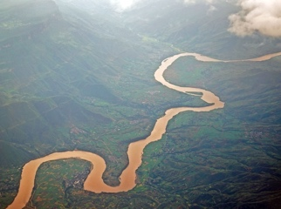  We will be learning about the features of rivers. Research the 3 longest rivers in the world. What countries can they be found in and what are they called?
Science: Living things. | Science: Living things and their habitats. | Science: States of matter
Classification. Animals can be classified into different groups based on their characteristics. Draw an animal that belongs in each of these groups.  insects, amphibians, fish, reptiles, birds, mammals. | What is your favourite animal? Write an informative paragraph about your favourite animal answering the following questions.  Is this animal an invertebrate or vertebrate? What is their habitat like? Do they hibernate? Are they a predator? What do they eat? What type of animal are they? EG fish, mammal. | Can you turn a solid into a liquid? With an adult's help, can you melt a solid (e.g. chocolate) into a liquid and observe the changes that happen? How did the item change when it changed state? Write or draw your findings.
History | Writing Diaries | French: seasons
What was life like for the Anglo-Saxons in Britain?  Research this question and create a colourful poster to share what you found. | We will be writing diaries. Can you write a diary about your weekend?  Remember to write in first person and use a range of conjunctions.  and if but because so even though however | Find out the French word for your favourite season. Research different words to describe this season’s weather and what you might wear during this season. Draw a picture of this season and label the weather and clothing in French.

