 MEDIUM TERM PLAN Year: 1 Term: Autumn 1
 |  | Week Beginning: | Week Beginning: |  | Week Beginning: | Week Beginning: | Week Beginning: | Week Beginning:
Diary Dates |  | 31/08/26 | 7/9/26 | 14/9/26 | 21/9/26 | 28/9/26 | 5/10/26 | 12/10/26
Shared Text – End of the day |  | Class Choice | Class Choice | Class Choice | Class Choice | Class Choice | Class Choice | Class Choice
Guided Reading Text |  | 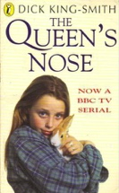  The Queen’s nose | The Queen’s nose | The Queen’s nose | The Raven  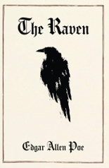 | The girl who stole an elephant  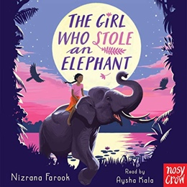 | The girl who stole an elephant | The girl who stole an elephant
- Writing |  | Poems which explore form | Persuasive writing | Persuasive writing | First person diaries | First person diaries | Critical analysis of poetry | Critical analysis of poetry
- Spelling |  | Baseline assessment and Homophones | Baseline assessment and Homophones | -ly Suffix | -ly Suffix | Statutory words | Statutory words | Prefixes
Maths |  | Place value | Place value | Place value | Place value | Addition and subtraction | Addition and subtraction | Addition and subtraction
RE  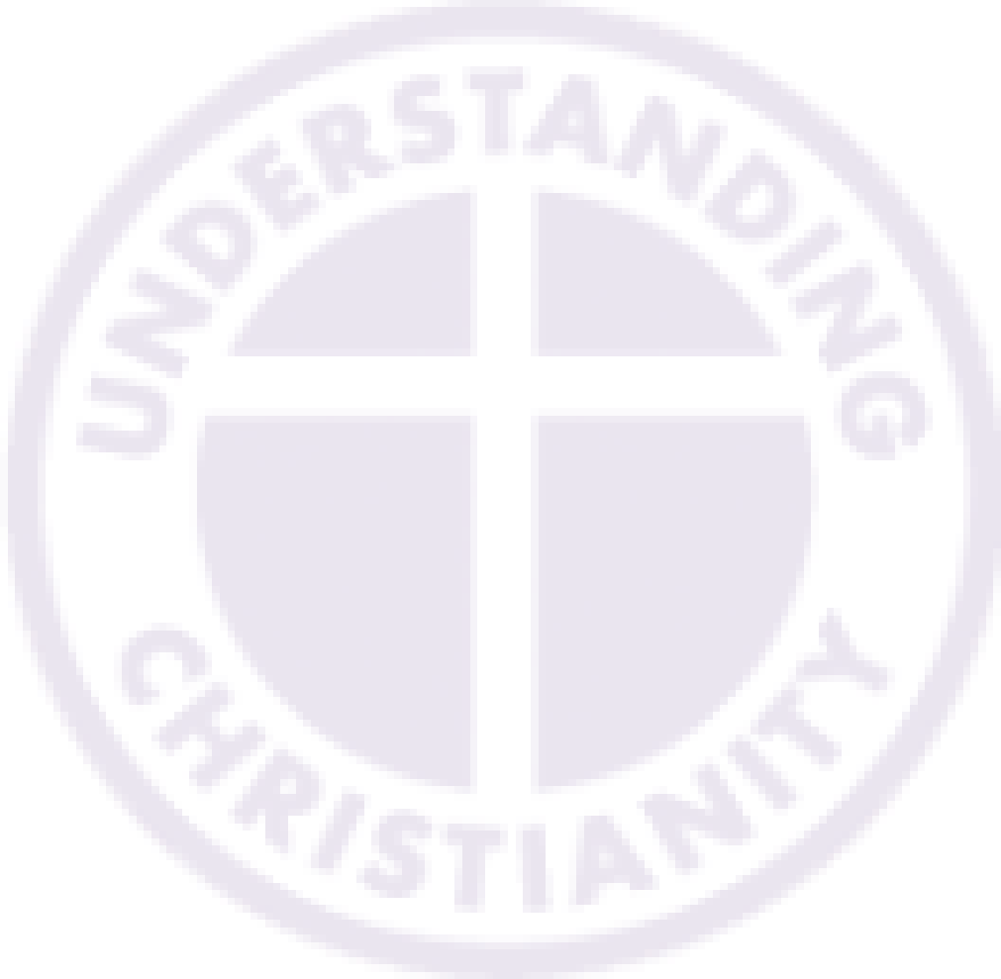  Key Question:  Unit 25  What kind of world did Jesus want? (Gospel) |  |  | What kind of world did Jesus want? | How does ‘fishers of men’ apply to Christians today? | What is an evangelist? | How did and does Jesus want people to act? | What does the Good Samaritan teach Christians? | What kind of world did Jesus want?
Science |  | Living things and  their Habitats  (7)  What are the characteristics of living things? | Living things and  their Habitats  (7)  What animals are vertebrates? | Living things and  their Habitats  (7)  What animals are invertebrates? | Living things and  their Habitats  (7)  What groups are plants classified in? | Living things and  their Habitats  (7)  What is classification? How do I use a key? | Living things and  their Habitats  (7)  What happens if the environment in a habitat changes? | Living things and  their Habitats  (7)  Review
Computing |  | E safety | Connecting networks | What is the internet made of? | Sharing information | What is a website? | Who owns the web? | Key Skills:  To create rules for using technology responsibly
Topic | History  Britain’s  settlement by Anglo  Saxons and Scots (6) | N/A | Why did the Anglo-Saxons come to Britain? | Where did the Anglo Saxons come from? | What was life like for Anglo-Saxons in Britain? | What kingdoms were formed by the Anglo-Saxons? | How do we know about the Anglo-Saxons? | How did religion influence the Anglo-Saxons? How do we know this?
Topic | Geography | N/A | N/A | N/A | N/A | N/A | N/A | What are the features of a river?
Topic | Art | Key Skills:  DRAWING  Introduce ‘composition’  of a group of objects to be used for still life | Key Skills:  DRAWING  Create contour drawings of the still life  Artist:  Morandi | Key Skills:  DRAWING  Record observations of  details | Key Skills:  DRAWING  Include detail after selecting appropriate  media and tools | Key Skills:  Drawing  Negative space – the space between the lines of the object drawn | Key Skills:  Drawing  Can reflect on things they would change or modify. | Artist Study
Topic | DT | N/A | N/A | N/A | N/A | N/A | N/A | N/A
PE |  | Netball  Gymnastic – Levels and Directions | Netball  Gymnastic – Levels and Directions | Netball  Gymnastic – Levels and Directions | Netball  Gymnastic – Levels and Directions | Netball  Gymnastic – Levels and Directions | Netball  Gymnastic – Levels and Directions | Netball  Gymnastic – Levels and Directions
Music |  | drumming | drumming | drumming | drumming | drumming | drumming | drumming
PSHCE  (Wellbeing, P4C, Circle time, Cultural capital) |  | Class Rules | Keeping Healthy | Get Moving | Sleeping | Press Pause | Healthy Eating | British Values

