
Year 2 Homework Grid
Autumn Term
Weekly homework: Reading, Spelling.
In addition, you may complete any of the following optional tasks this term and choose how you present them!
DT: Textiles | Science: Living things and their habitats | English: Christmas Poem
This term we will investigate textiles and how ro repurpose fabric. We will be taught how to complete a straight stitch to sew. Can you use a straight stitch to sew a small simple bag design?  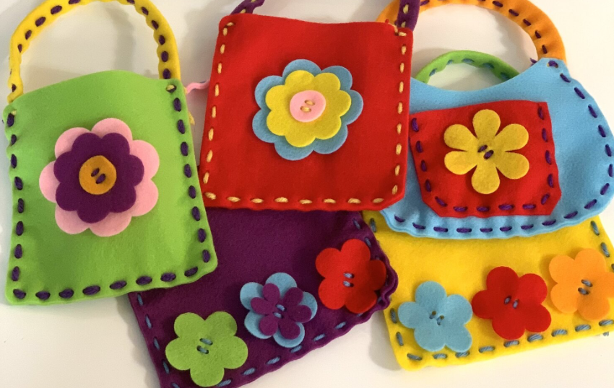 | Can you make a habitat for animals? It can be the desert, arctic, seaside or any other, maybe even a microhabitat.  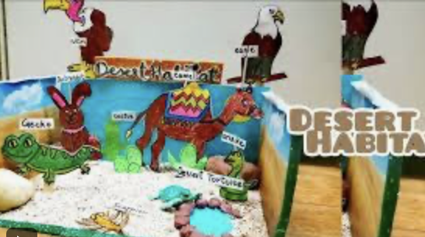 | Can you create a Christmas poem? It does not have to rhyme if you do not want it but it has to be presented with decorations.  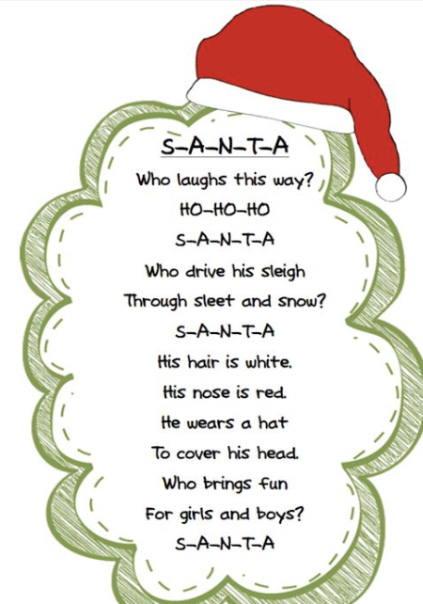
Computing: Digital photography | History | PE: Fitness challenge
After half term we will be learning about digital photography. Can you take a picture of anything interesting in nature and bring it to school to discuss about it?   | Can you create an image of the burning houses during the Great fire of London? You can use paint, collage, drawing or any other materials.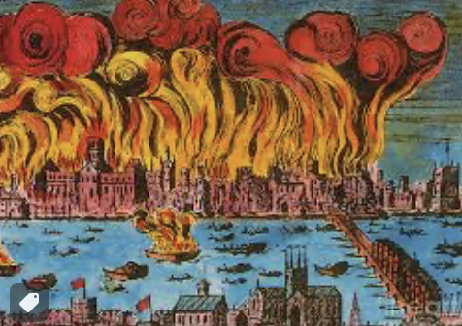 | Can you complete the fitness challenge from the class page? How many days can you do those activities? 

