Year 2 Spelling Overview- Autumn Term
Block 1 common exception words y1 revisited, y2 introduced
Etymology: bi
weeks beginning 01.09.26 and 07.09.26
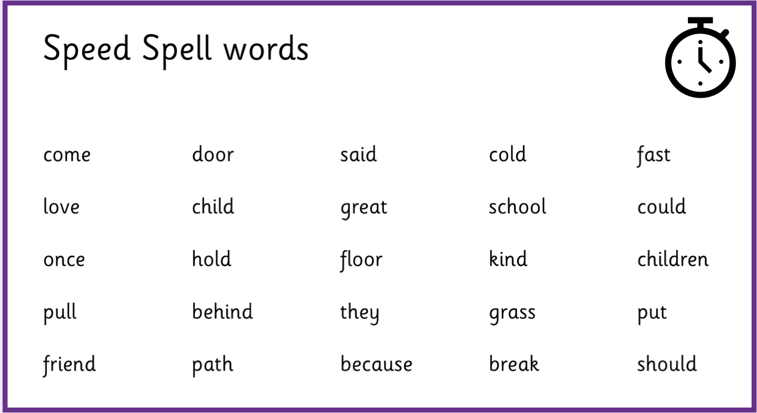
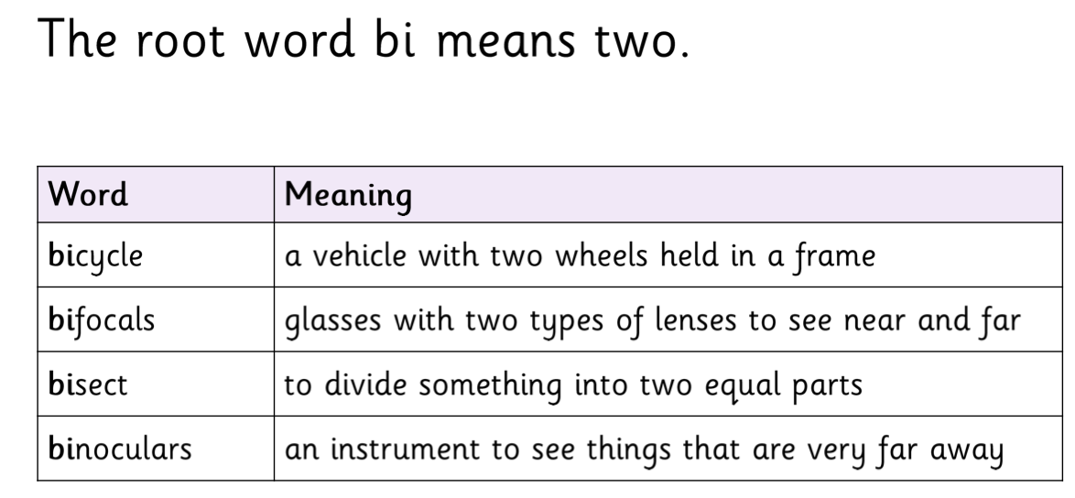

Block 2
Concept: The /d3/ sound spelt -ge and -dge at the end of words
Etymology: oct
weeks beginning 14.09.26 and 21.09.26
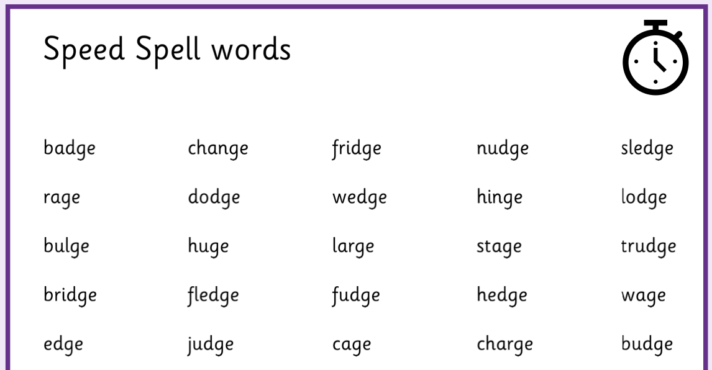
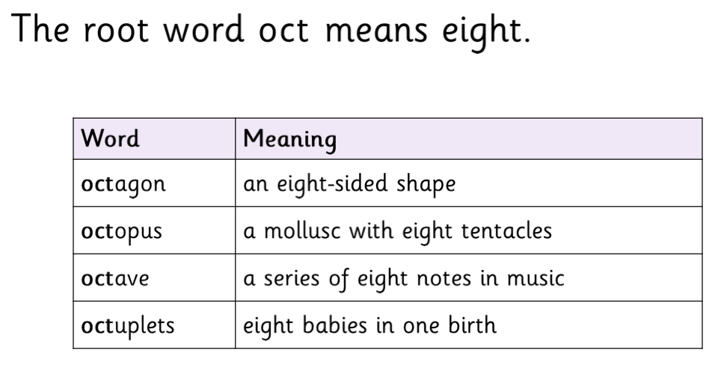

Block 3
Concept: The /d3/ sound spelt g elsewhere in words before e, I and y and j before a, u and o
Etymology: penta
weeks beginning 28.09.26 and 05.10.26
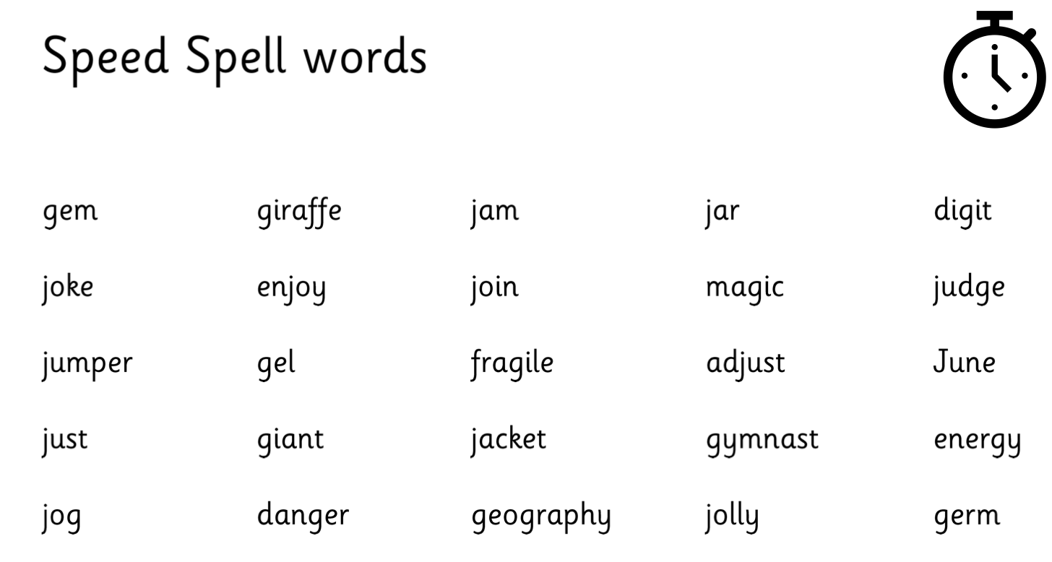
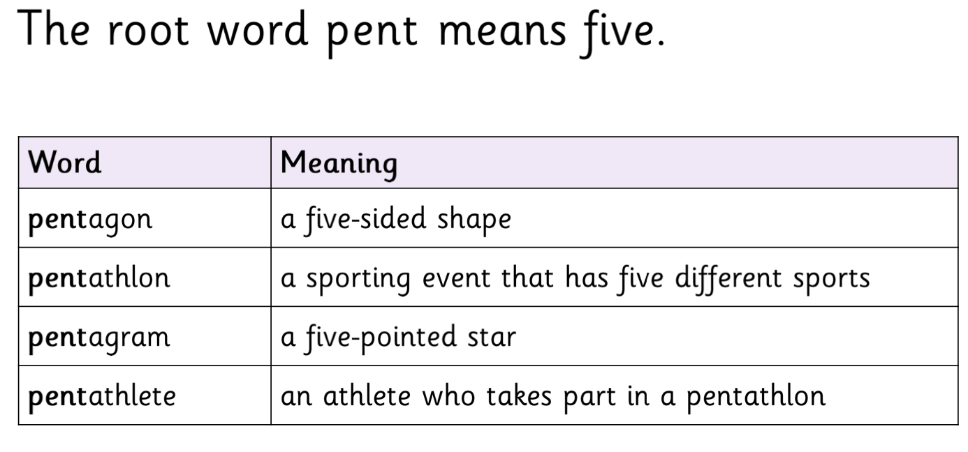

Block 4
Concept: The /s/ sound spelt c before e, i and y
Etymology: hex
weeks beginning 12.10.26 and 02.11.26
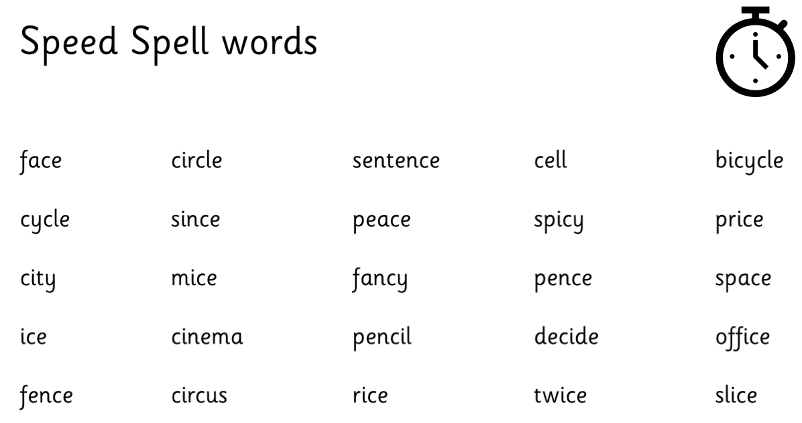
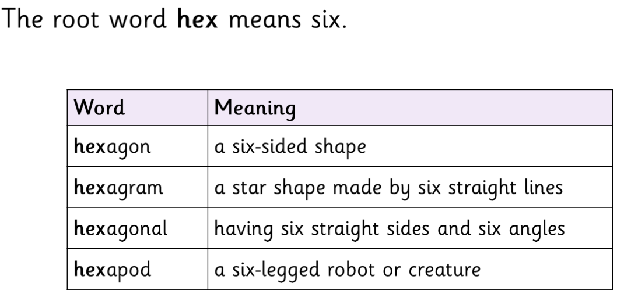

Block 5
Concept: The /3/ sound spelt s
Etymology: quad
weeks beginning 09.11.26 and 16.11.26
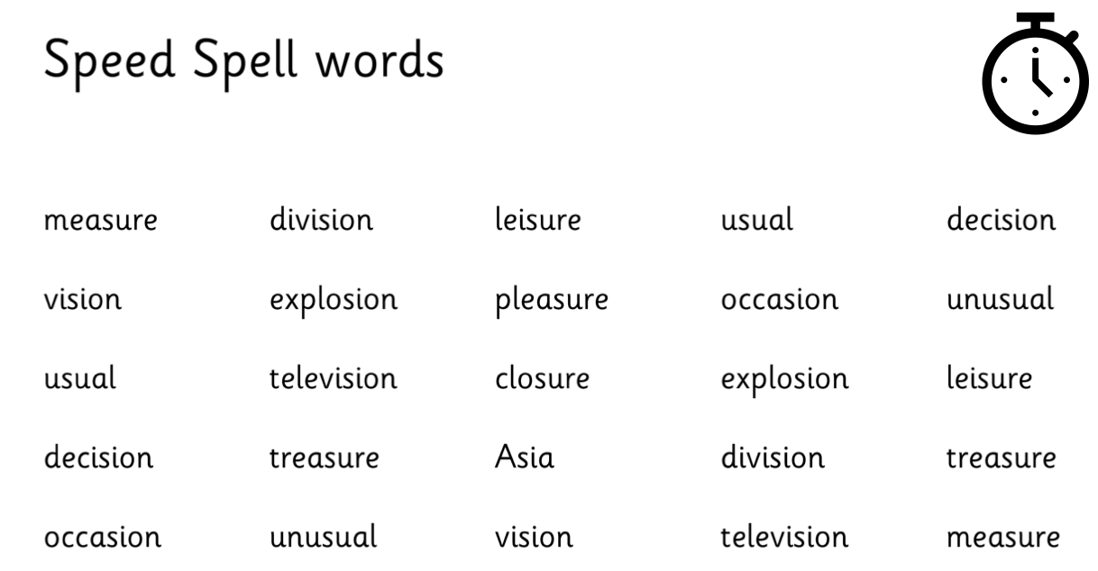
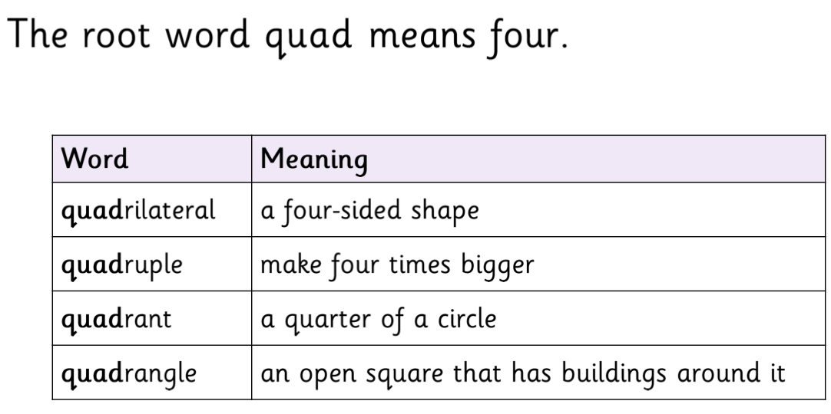

Block 6
Concept: Homophones and near-homophones
Etymology: wise
weeks beginning 23.11.26 and 30.11.26
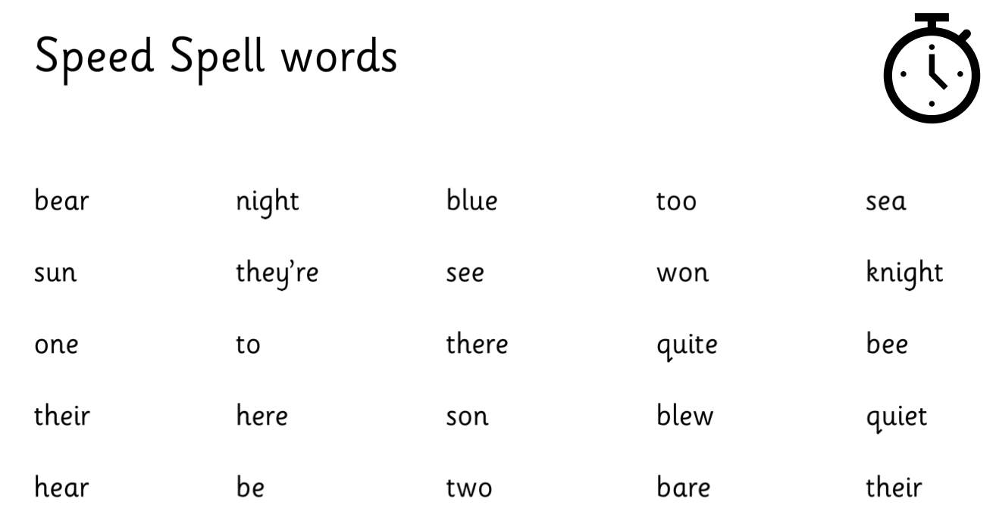
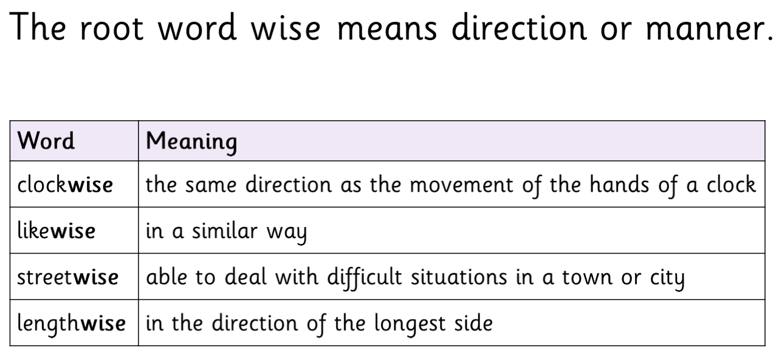

Block 7
Concept: Common exception words
Etymology: quart
weeks beginning 07.12.26 and 14.12.26


