Year 2 Spelling Overview- Summer Term
Block 4 (revisiting)
Concept: The /s/ sound spelt c before e, i and y
Etymology: hex
weeks beginning 13.04.26 and 20.04.26
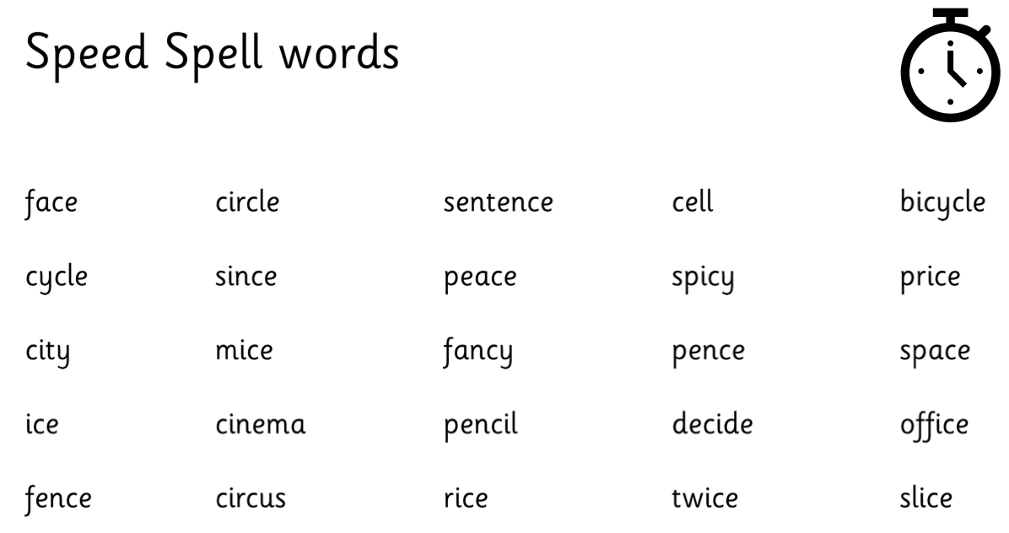
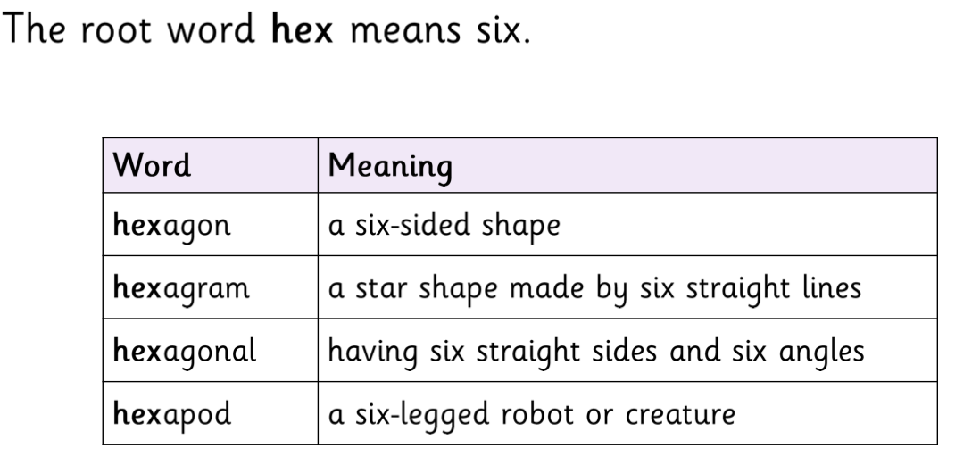

Block 13
Concept: The /o/ sound spelt a after w and qu. The /er/ sound spelt or after w. The /or/ sound spelt ar after w
Root word: trans
weeks beginning 27.04.26 and 04.05.26
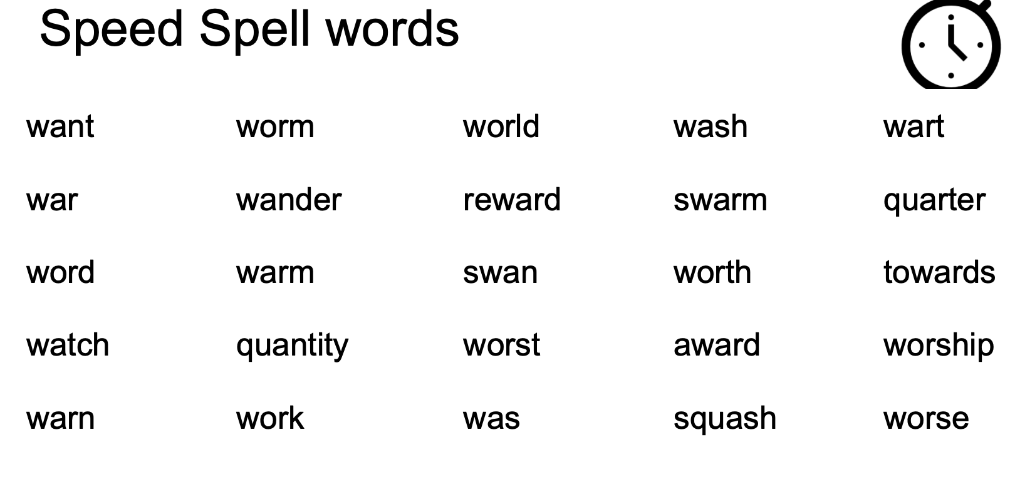
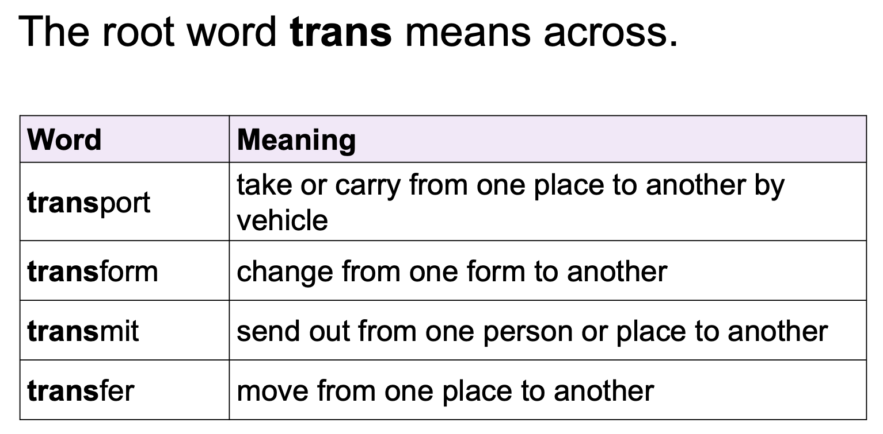

Block 5
Concept: The /3/ sound spelt s
Etymology: quad
weeks beginning 11.05.26 and 18.05.26
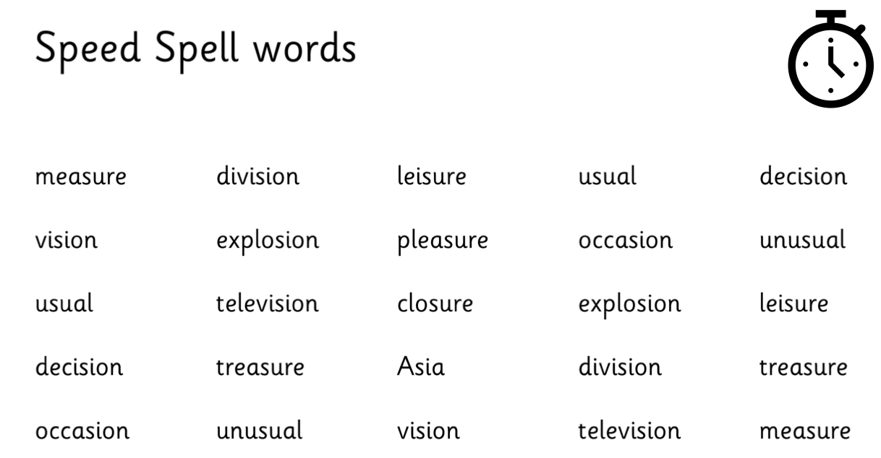
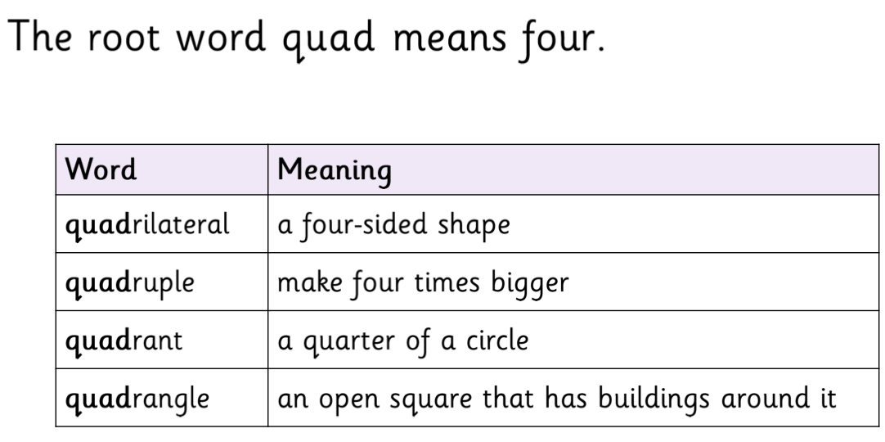
Block 14
Concept: The suffixes –ment, –ness, –ful,
–less and –ly
Root word: loc
weeks beginning 01.06.26 and 08.06.26
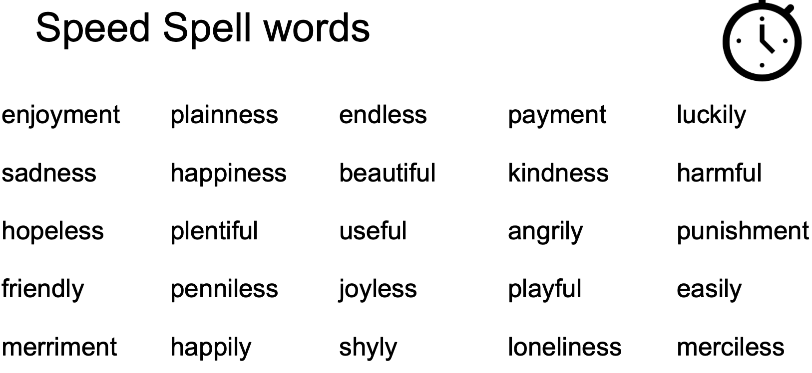
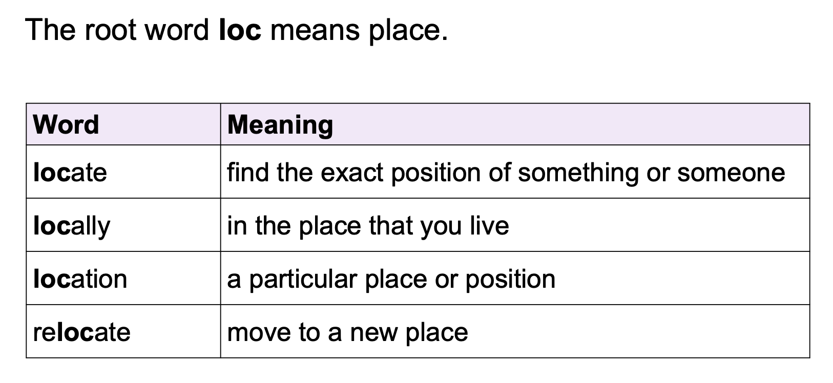

Block 15
Concept: Contractions
Root word: dent
weeks beginning 22.06.26 and 29.06.26
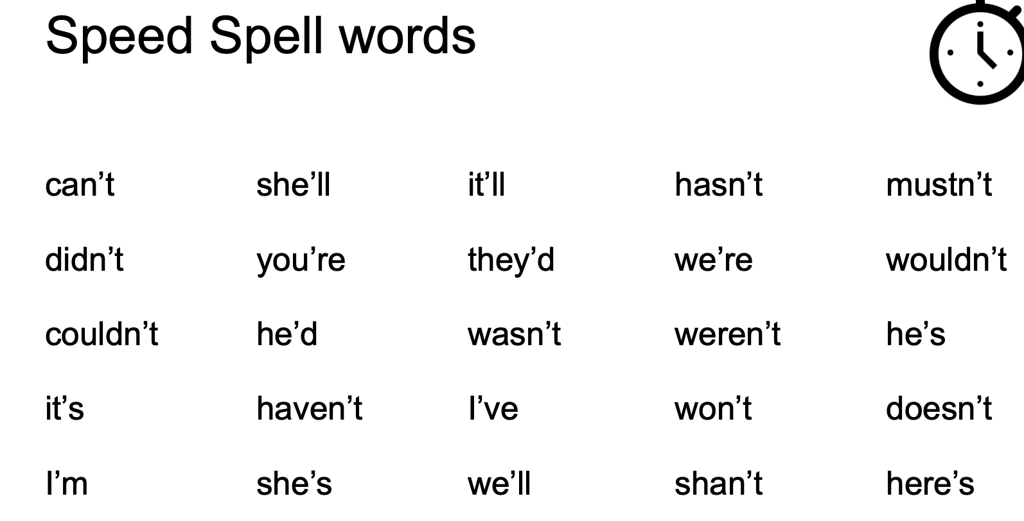
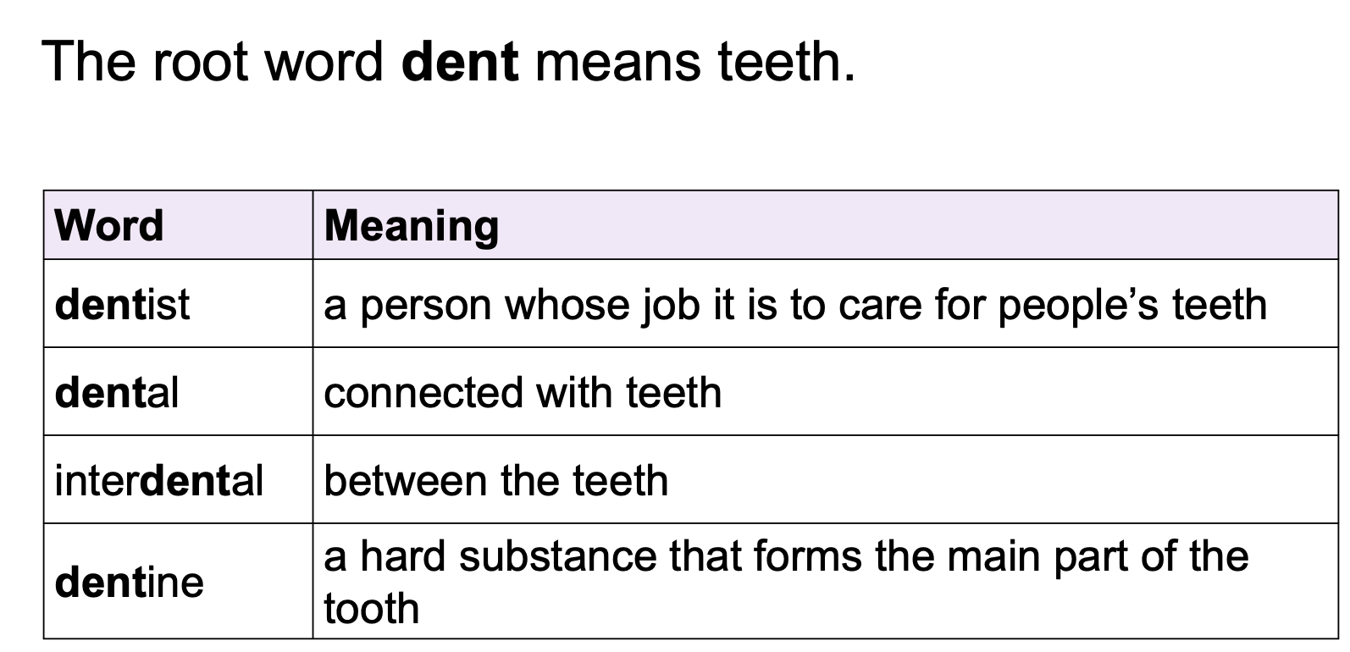

Block 16
Concept: Words ending in -tion
Root word: equi
weeks beginning 06.07.26 and 13.07.26
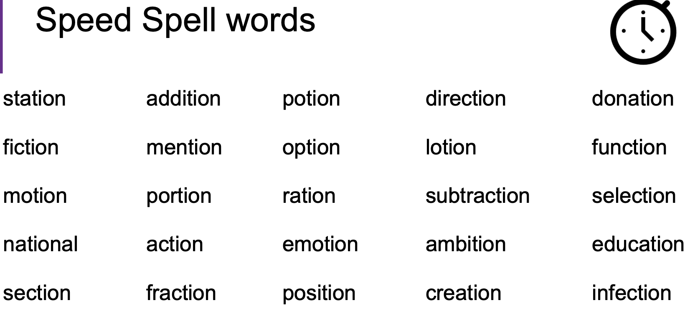
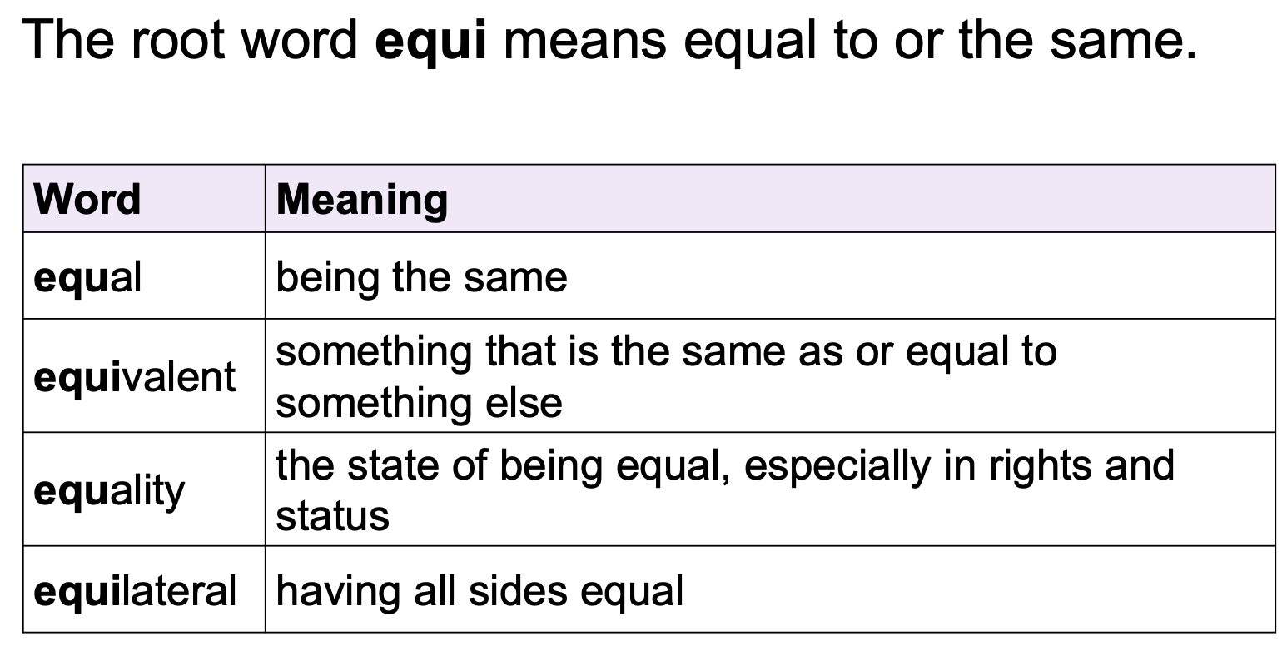

Block 11
Concept: Adding -es to nouns and verbs ending in -y Adding-ed, -ing, -er and -est to a root word ending in —y with a
consonant before it
Etymology: vore
weeks beginning 13.07.26 and 20.07.26


