
Year 2 Homework Grid
Summer Term
Weekly homework: Reading, Spelling, TTRS weekly activity.
In addition, you may complete any of the following optional tasks this term and choose how you present them!
DT: Structures | English: Poster | Computing/ Maths
This term we will investigate different structures with the question of How strong is a piece of paper? in mind. Can children attempt to create a bridge structure, entirely out of paper or card to hold a small toy car zooming across as a test?  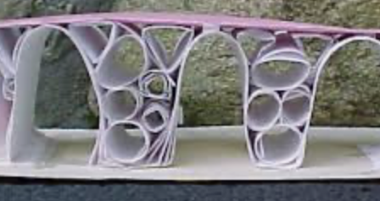 | Can you make a poster bout one great woman who changed the world of your own interest and choice?  Present facts neatly and in an interesting manner, use pictures, drawings and sub-headings.  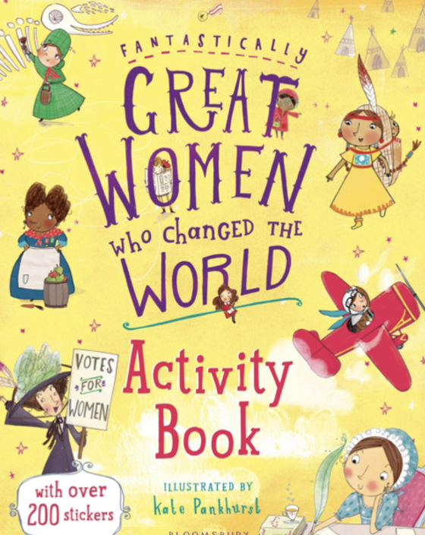 | Can you create a pictogram to collect data about anything that interests you? It can be :how many vehicles pass your house in one hour? or How many people in your family have blue eyes?  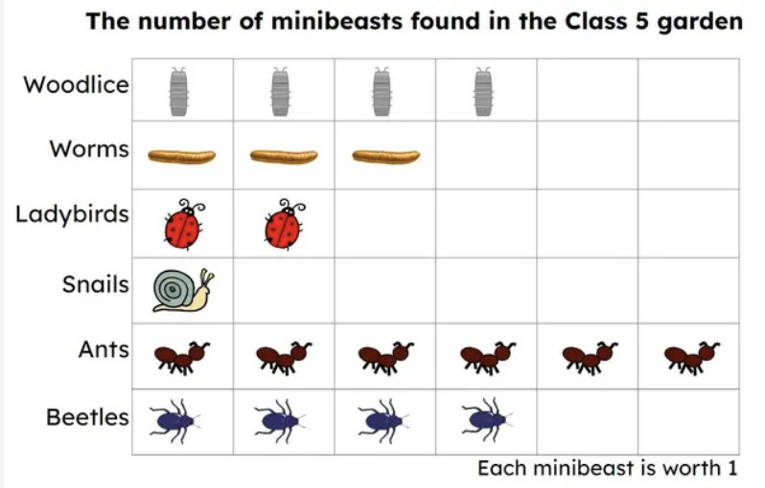
Art: Seaside collage | Science: Parts of a plant | PE: Fitness challenge
Make a seaside collage. You can use any media and any creature or landscape from the seaside.  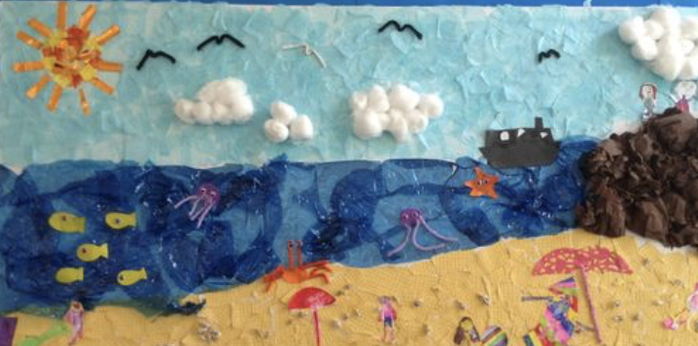 | Can you create a poster to explain the main parts of a plant and their uses. Please present it neatly, adding labels and information as well as drawings or phptographs.  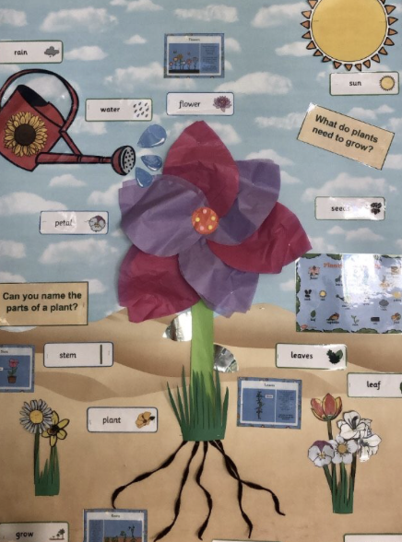 | Can you complete a fitness challenge?  For two weeks, each day, you have to see how many squats can you do in 1 minute. Find a way to record on a piece of paper and bring the challenge to school to show in assembly.  

