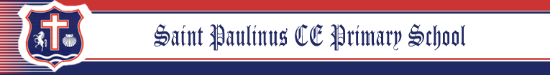
Y1 Homework Grid -Summer
Weekly homework: Reading, Maths
In addition, you may complete any of the following optional tasks this half term and choose how you present them!
DT & Science & Writing- Food | RE - Muslim, Hindu, Jewish Faiths | Geography- Mapping and fielding
In Summer term, we’re exploring where our food comes from! 🌍🍎👇 Here’s what to do:  🔍 Go on a food hunt!  Visit an allotment 🪴 or a supermarket 🛒 with an adult and pick out some fruits 🍌 or vegetables 🥕.  🌱 Investigate:  Where do they come from? 🗺️  Do they grow in the ground 🌾, on a plant 🌿, or on a tree 🌳?  👩‍🍳 Get cooking!  With your parents, use your fruits or veggies to make a simple dish 🍲.  Take a photo 📸 of what you made!  Write down the recipe 📝 – include ingredients and steps.  🗂️ Bring it all together:  📷 A photo of your dish  📝 The recipe (neatly written to show at the celebtation assembly)  Have fun being a food explorer and mini chef!  Bon appétit! 🍴👨‍🍳👩‍🍳 | This half term, we are learning about how stories help people understand their faith and values. Your homework is to explore one of these faith traditions: Muslim, Hindu, or Jewish.  🤔 Choose one faith to learn about:   Islam (Muslim)   Hinduism (Hindu)  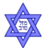Judaism (Jewish)  📖 Find a story from that faith. You can:  - Read a children’s book or look online with help from an adult.  - Ask someone you know who follows that faith 🗣.  - Watch a short video made for kids.  🧠 Learn the story and think about:  - Who are the main characters?  - What happens in the story?  - What lesson or message does the story teach?  - Draw or write:  - Draw a picture from the story and write 3–4 sentences about it. | 📝 Task: Create Your Own Map!  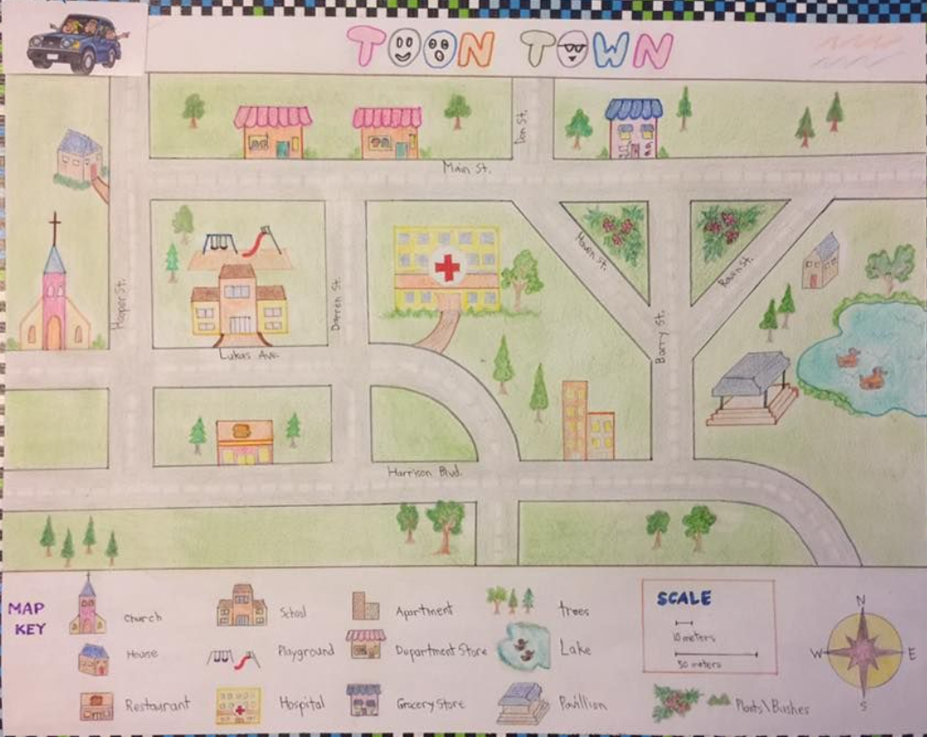  Become a young cartographer (that means a map-maker)! Your job is to draw your own map of a place you know well. It could be:  Your local park, school playground or even a made-up island!  Here’s what your map should include:  ✅ A title for your map  ✅ A compass rose (with North, South, East, and West)  ✅ A key (or legend) that shows what the symbols on your map mean  ✅ At least 3 physical features (like hills, rivers, trees)  ✅ At least 3 human features (like buildings, roads, bridges)  Challenge Time!  Can you write 3-5 sentences that describe where your features are using direction words?  For example:  "The playground is north of the school building."  "The river runs from the east to the west of the map."  "The library is just south of the big tree."

