

MEDIUM TERM PLAN
Year: EYFS Term: Spring 1

 |  | W/B  05.01.26 | W/B  12.01.26 | W/B  19.01.26 | W/B  26.1.25 | W/B  02.02.26 | W/B  09.02.26
Diary Dates |  |  | Educational Visit to Sainsburys / Charity Shop TBC |  | 30th- Taking Paintings Interactive Tour-  National Gallery Trip | Education Sunday on 8th February | 10th – Safer Internet Day  14th – Valentines Day  17th -Chinese New Year
Literacy | Shared Text – End of the day | Children’s choice | Children’s choice | Children’s choice | Children’s choice | Children’s choice | Children’s choice
Literacy | English Text | Katie and the Starry Night  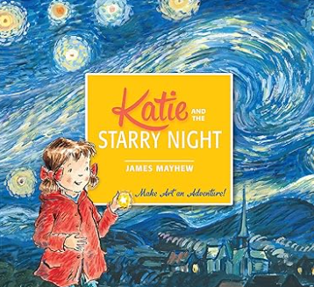 | It’s A No Money Day  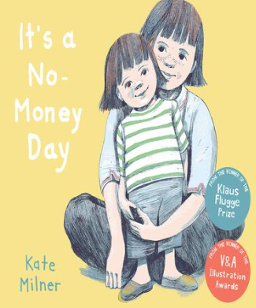 | The Story Orchestra  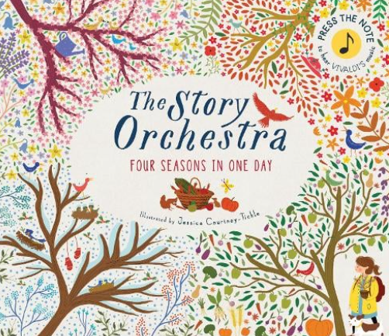 | Luna Loves Art  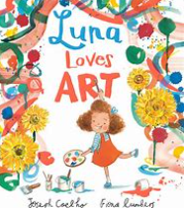 | Chicken Clicking  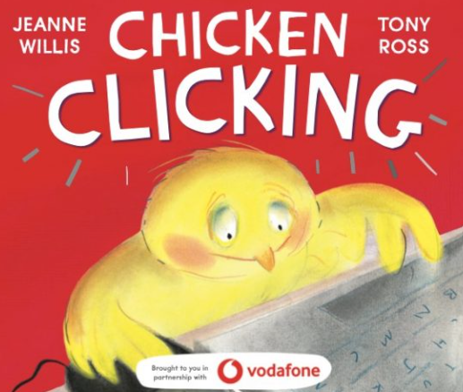 | I Love Chinese New Year  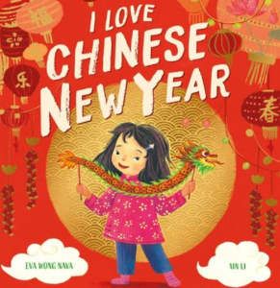  How to catch a Dragon
Literacy | Writing | Comprehension:  Demonstrate understanding of what has been read to them by retelling stories and narratives using their own words and recently introduced vocabulary.  - Anticipate (where appropriate) key events in stories.  - Use and understand recently introduced vocabulary during discussions about stories, nonfiction, rhymes and poems and during role play.  Word Reading  - Say a sound for each letter in the alphabet and at least 10 digraphs.  - Read words consistent with their phonic knowledge by sound-blending.  - Read aloud simple sentences and books that are consistent with their phonic knowledge, including some common exception words.  Writing  - Write recognisable letters, most of which are correctly formed.  - Spell words by identifying sounds in them and representing the sounds with a letter or letters.  - Write simple phrases and sentences that can be read by others.
Literacy | Phonics | ELS  Review + oo | ELS  ar,ur, oo, or | ELS  ow, oi, ear, air | ELS  ure, er, ow | ELS  Review | ELS  Review

Communication and language |  | Continuous discussions throughout the day | Continuous discussions throughout the  day | Continuous discussions throughout the day | Continuous discussions throughout the day | Continuous discussions throughout the day | Continuous discussions throughout the day | Continuous discussions throughout the day
Maths |  | WRM –  Alive in 5 Introduce zero Find 0-5  Subitise 0-5  Represent 0-5 | 1 more  1 less Composition  Conceptual subitising to 5 | WRM –  Mass and Capacity  Compare mass Find a balance Explore capacity Compare capacity | Review | WRM –  Growing 6, 7, 8  Find 6, 7, 8  Represent 6, 7, 8  1 more  1 less | Composition of 6,  7 and 8  Make pairs – odd and even  Double to 8 (find a double)  Double to 8 – make a double | Combine 2 groups  Conceptual subitising  WRM – Length, height and time  Explore length Compare length
RE  Being special to God and where we belong.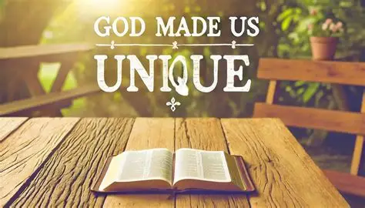 |  | What makes us feel special?  What makes many Christians feel that they are special to God? | Why do many Christians believe that children are special to God? | Which groups do some religious people belong to? | How do we show people they are welcome?  How are babies welcomed into the Christian family? | How are some babies welcomed in the Muslim tradition? | How do Hindu brothers and sisters show their love for each other at a festival? | Review
Understanding the World | Past & Present | Art and technology now and then | Different people in the community |  |  | History of the Lunar New Year |  | Roles of people in the community (farmers, delivery  drivers, post people)
Understanding the World | People, Culture & Communities | Famous artists  Vicent van Gogh | Foodbanks and charity shops | Biomes |  | Chinese New Year Celebrations Across the Globe |  | Knowing where I live and where key features are around me eg Post Office (link to maps) Knowing the difference between: international, national and local  travel / transport
Understanding the World | The Natural World |  | The states of matter |  | Animals and their habitats Food chains |  | Exploring space | Knowledge of lifecycles and food chains

 | Twigs and trees Thursday |  | Free games for everyone | Creating music using natural resources | Wondrous Adventures | Lunar New Year Parade | Drama – create the end scene for Chicken Clicking in  the forest
Expressive Arts and Design | Music | Education Sunday Songs | Education Sunday Songs | Education Sunday Songs | Education Sunday Songs | Education Sunday Songs | Education Sunday Songs
Expressive Arts and Design | Art/DT | The Starry Night | Junk modelling | Crafting masks and instruments | Various papercrafts | Exploring watercolours | Internet Safety Posters  Photography
Physical development | PE -  Early Gymnastics | High, Low, Over, Under  Introduction to High | High, Low, Over, Under  Introduction to Low | High, Low, Over, Under  Introduction to the Apparatus | High, Low, Over, Under  High and Low on the apparatus | High, Low, Over, Under  High, Low, Over, Under | High, Low, Over, Under  High, Low, Over, Under extended
Personal, Social, Emotional Development |  | Continuous  throughout day | Continuous  throughout day | Continuous  throughout day | Continuous  throughout day | Continuous  throughout day | Continuous  throughout day
Other areas of learning | Role play  area | Inside: Shop  Outside: Mud Kitchen, theatre, construction, home corner
Other areas of learning | Outdoor  areas | Writing area, Maths area, Reading area, Mud kitchen, planting, art area, sand, water, construction, physical

