 MEDIUM TERM PLAN Year: 1 Term: Spring 1
 |  | Week Beginning: | Week Beginning: | Week Beginning: | Week Beginning: | Week Beginning: | Week Beginning: | Week Beginning:
Diary Dates |  | 05.01.2026 | 12.01.2026 | 19.01.2026 | 26.01.2026 | 02.02.2026 | 9.02.2026 | 17.02.2025
Shared Text – End of the day |  | Class Choice | Class Choice | Class Choice | Class Choice | Class Choice | Class Choice | Half term Break
English Text |  | N/A | 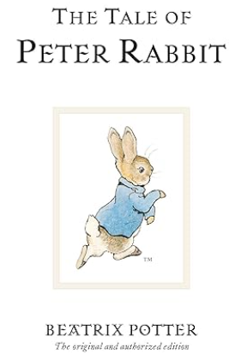 |  |  | 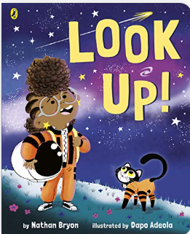
- Reading |  | N/A | Focus on the core text for prediction and retrieval Focus on the biography for retrieval | Focus on the warning signs for inference and the core text for a personal response | Focus on the core text for retrieval and sequencing Focus on the poem for summarising | Focus on the core text for retrieval Focus on the core text and information text for understanding themes | Focus on the pamphlet for inference and the core text for a personal response
- Writing |  | Strong Start  Sentence Composition  -To know that sentence contains a subject, nouns and expresses a complete thought  -To identify nouns and verbs  -To correct commas in a basic sentence composition | Recount | Recount | Recap based on writing task from previous week. | Informal letter | Informal letter
- Phonics |  | Essential Letters and sounds scheme | Essential Letters and sounds scheme | Essential Letters and sounds scheme | Essential Letters and sounds scheme | Essential Letters and sounds scheme | Essential Letters and sounds scheme
Maths |  | Place Value within 20  count within 20  understand 10  understand 11,12,13 | Place Value within 20  Understand 14,15,16  Understand 17,18,19  Understand 20 | Place Value within 20  1 more and 1 less  Number line to 20  To use a number line | Place Value within 20  estimate using a number line  compare numbers to 20  Order numbers to 20 | Addition and subtraction within 20  add by counting on within 20  adding ones using number bonds  find and make number bonds to 20 | MONEY
RE |  |  |  |  |  |  | ASSESSMENT
Science |  | New topic: Animals including humans  What is an animal? | What types of animals are there? | What is similar and what is different? | What does food tell us about an animal? | What makes me an animal? What senses do I have? | ASSESSMENT
Computing |  | Moving a robot: Buttons | Moving a robot: directions | Moving a robot: forwards and backwards | Moving a robot: four directions | Moving a robot: Getting there and routes | REVISION
Topic | History | N/A
Topic | Geography | Remember, Name and Find the 7 continents and 5 oceans of the world.  Where is the Equator? | Where is hot and cold on the Earth? | Where are the North and South Poles? What are they like? | Where can I find hot countries? What are they like? | What do I know about hot and Cold places? | REVISION
Topic | DT | Structures:  Explore how the size of a base affects the  stability of a tower and how tall it can be built | Structures:  Explain what balance  means and how balance  affects the stability of a  tower  Explain what a  foundation is and how  this creates stability | Structures:  Explore different methods of joining cardboard for construction purposes Decide which types of joins would be most effective for use in building a tower | Structures:  Create a design based on knowledge of what makes a tower stable | Structures:  Use construction materials such as cardboard to build a freestanding structure | EVALUATION
PE |  | Ball Skills  Wide, Narrow and Curled Gymnastics | Ball Skills Wide, Narrow and Curled Gymnastics | Ball Skills Wide, Narrow and Curled Gymnastics | Ball Skills Wide, Narrow and Curled Gymnastics | Ball Skills Wide, Narrow and Curled Gymnastics | Ball Skills Wide, Narrow and Curled Gymnastics
Music- Collins Connect |  | Music from around the world  Skill: Performing | Combining voices, movement and instruments to perform a chant and a song | Keeping a steady beat on instruments Creating word rhythms Performing word rhythms with movement | Keeping a steady beat Playing and combining simple word rhythms Responding to music in movement | Performing to peers | REVISION
MFL |  | n/a | n/a | n/a | n/a | n/a | n/a
PSHCE  (Wellbeing, P4C, Circle time, Cultural capital) |  | My life: friends and family | My life: personal safety | My life: personal safety, continued | My life: being proud | Children's mental health week 3rd-7th Feb | My Life
Outdoor Learning
Visits/visitors |  |  |  |  | NSPCC Number Day | E- Safety Day  Children’s Mental Health week

