
Y4 Homework Grid Spring
Weekly homework: Reading, times tables practice and TTRS online.
In addition, you may complete any of the following optional tasks this term and choose how you present them!
Science:-Animals-including-humans-digestion-teeth-and-food-chains | Science: -Animals-including-humans-digestion-teeth-and-food-chains | Science:-Animals-including-humans-digestion-teeth-and-food-chains States of matter
Digestion Process  Write a short description (3-4 sentences) of how food is digested in the human body. Start with chewing and end with the food being absorbed into the bloodstream.  Tip: Think about what happens when food enters your mouth, travels down your esophagus, and moves through your stomach and intestines. | Types of Teeth in Humans  Draw and label the different types of teeth in the human mouth (incisors, canines, premolars, and molars). Write a sentence about what each type of tooth is used for. | Create Your Own Animal Food Web:  Using at least 5 different animals and plants, create a food web. Show how they are all connected and how they rely on each other for survival.
Writing: Write a story | Writing | Writing: Persuasive writing
Using what you’ve learned about the culture, create your own short story.  Your story should:  Include at least one character or creature from the culture’s folklore or mythology.  Incorporate a lesson or value that is important in that culture (for example: the importance of kindness, bravery, respect for nature, etc.).  Be imaginative: You can write a modern story or set it in the past, but make sure to respect the culture’s traditions while being creative! | Can you write sentences using coordinating conjunctions?  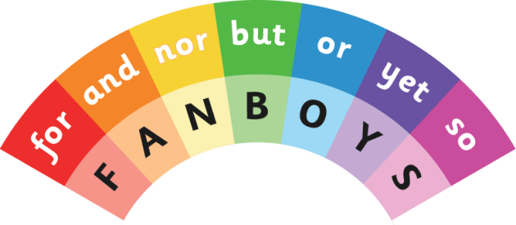 | We will be learning about persuasive adverts and how they use emotive language, superlatives and rhetorical questions to sell their message.  Choose your favourite toy. Design an advert to convince someone to buy this toy.
History/Geography | DT- Food technology | French- Food
Identify locations of Viking settlements on a map. | Make some homemade soup and write the recipe for others to use. Did you enjoy the soup? | Draw 5 pieces of food and label them in French.

