
YR5 Homework Grid – Autumn
Weekly homework: Reading, Spelling, TTRS, Maths sheet.
In addition, you may complete any of the following optional tasks this term and choose how you present them in your homework folder!
Art: Drawing and Painting | DT: Food and Nutrition | Science: Properties of Materials
Can you create a portrait of a family member that focuses on subtractive drawing? Try to use different mediums like paint, pencils, chalk and charcoal. 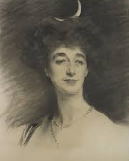  Remember: Subtractive drawing is when pieces are removed to create your final outcome | Create a meal from another country. Ensure it is nutritious and explain why you believe this is a nutritious and balanced diet. Take pictures of the steps you took to make it and also the final piece.  Did you like it?  What would you do differently next time? | Evaluate several everyday products, identifying the properties they need and the materials that would be suitable to make form. What are the properties that products need to be able to fulfil their need: hard, soft, strong, weak, flexible, bendy, and recyclable?
Science: Forces | RE: Christianity | PSHE: My Mind
Why do things fall towards the earth? What forces are acting upon objects? Can you research this and present your information. You could even take part and explain the experiment below.  In your own time find 3 objects around your house that are not breakable e.g. a pillow, a feather and a teddy and drop them all from the same height. Explain what happened and why you think it happened. | Create a poster explaining how Christians view God.  Remember the key words from our unit:  Eternal, holy, spirit, omnipotent, omniscient, omnipresent and loving. | Create a poster for children in Year 3 and 4 explaining why it is important to manage yourself and give advice on how they can cope when things become challenging. 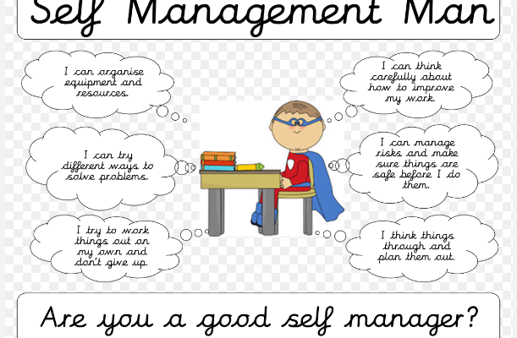
Geography: Biomes | History: Ancient Greece | PE: Communications and Tactics
Draw a poster comparing these three continents: Europe, North America and South America.  Think about the climate, mountains and biomes. | Create a character profile of a Greek God of your choice. | Create a game that requires Year 5 to work as a team with great communication skills. Write out the rules of this game. You may be luckily enough to lead this game in one of our PE lessons.

