 MEDIUM TERM PLAN Year: 1 Term: Autumn 1
 |  | Week Beginning: | Week Beginning: |  | Week Beginning: | Week Beginning: | Week Beginning: | Week Beginning:
Diary Dates |  | 1/9/25 | 8/9/25 | 15/9/25 | 24/9/25 | 29/9/25 | 6/10/25 | 13/10/25
Shared Text – End of the day |  | Goldilocks and three bears  Colour Monster  Splat the Cat | Peace at Last  Mr Large in Charge  The Gruffalo | The Day the crayons quit  Zog | The Gruffalo’s Child  Snail and The Whale  What the Ladybird Heard | The Space Tortoise  The Marvellous Moon Map | The Owl and the Pussycat  Squirrels that squabbled  The Cave Baby | The Green Ship  Mog the Forgetful Cat  The Squash and the Squeeze
English Text |  | Family and Me  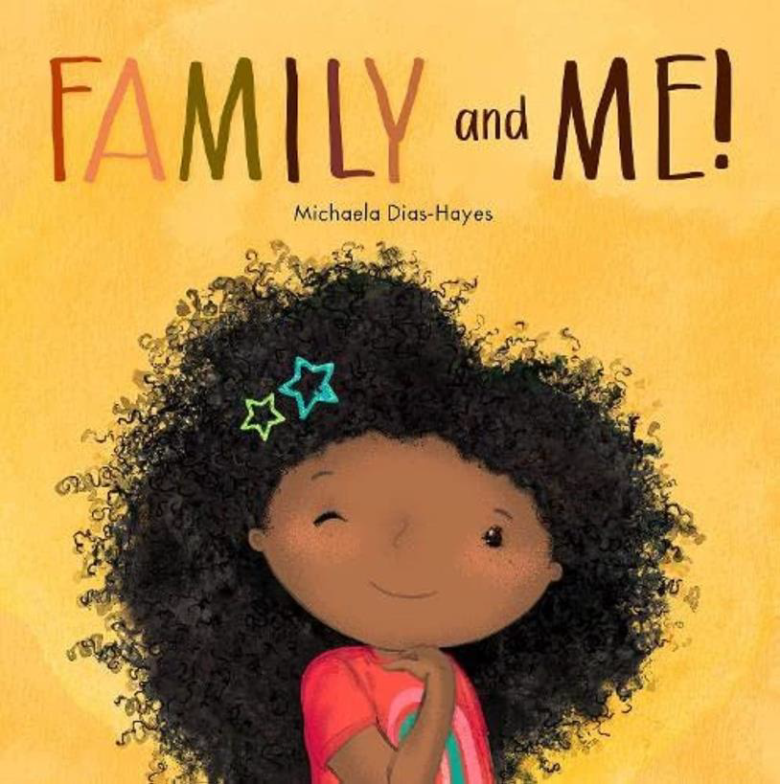 | 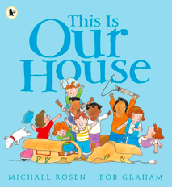  This is Our House | 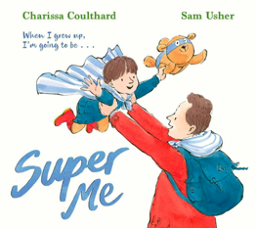  Super Me | Beegu  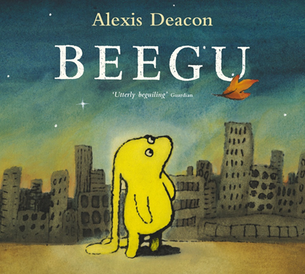 | Beegu | Where the Wild Things Are  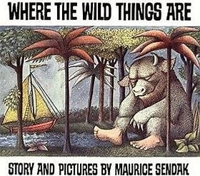 | Where the Wild Things Are
- Reading |  | Structured Story Time | Structured Story Time | Structured Story Time | Beegu Predictions and Comprehension | Beegu Inference | Reading Comprehension  Skills | Reading Comprehension  Skills
- Writing |  | Use of capital letters and full stops | Use of capital letters and full stops | Use of capital letters and full stops | Use of capital letters and full stops | Poetry-Pattern and Rhyme | Setting Descriptions | Setting Descriptions
- Phonics and/or spelling |  | Baseline assessment | Review Week 1 | Review Week 2 | ay ou ie ea | oy ir ue aw | Review Week 3  Assessment | wh ph ew oe
Maths |  | Baseline Assessment | Place value (within 10)  read and write numbers from 1 to 20 in numerals and words. | Place value (within 10)  identify and represent numbers using objects and pictorial representations | Place value (within 10)  the number line, and use the language of: equal to, more than, less than (fewer),most, least | Place value (within 10) | Addition and Subtraction | Addition and Subtraction
RE |  | Key Question:  CRIBS | Key Question:  CRIBS | Key Question:  CRIBS | Key Question:  CRIBS | Key Question:  CRIBS | Key Question:  CRIBS | Key Question:  CRIBS
Science |  | Key Question:  SEASONS  What are the four seasons? | Key Question:  SEASONS  What’s the weather like? |  | Key Question:  SEASONS  Why does day become night? | Key Question:  PLANTS  What are the parts of a plant? | Key Question:  PLANTS  What are wild plants? | Key Question:  PLANTS  What makes a tree?
Computing |  | Key Skills:  Technology in our classroom. | Key Skills:  To identify a computer and its main parts | Key Skills:  To use a mouse in different ways | Key Skills:  To use a keyboard to type on a computer | Key Skills:  To use a keyboard to type on a computer | Key Skills:  To use the keyboard to edit text | Key Skills:  To create rules for using technology responsibly
Topic | History | - | - |  | - | - | - | -
Topic | Geography | N/A | Key Question:  What are the 7 continents  of the world?  Where are they? | Key Question:  What are the 5 oceans of the  world? Where are they? | Key Question:  Where are the 4  countries of the  United Kingdom? | Key Question:  What are the 4 capital  cities of the United  Kingdom? Where are they? | Key Question:  What seas and oceans  surround the United  Kingdom? | Consolidation
Topic | Art | Key Skills:  DRAWING  Exploration of Materials | Key Skills:  DRAWING  Explicit teaching and techniques  Artist:  Albrecht Durer | Key Skills:  DRAWING  Application of knowledge and techniques | Key Skills:  DRAWING  Final Piece | Key Skills:  PAINTING  Exploration of Materials | Key Skills:  PAINTING  Explicit teaching and techniques  Artist:  Piet Mondrian | Key Skills:  PAINTING  Application of knowledge and techniques
Topic | DT | - | - |  | - | - | - | -
PE |  | Health and Wellbeing  Team Building | Health and Wellbeing  Team Building | Health and Wellbeing  Team Building | Health and Wellbeing  Team Building | Health and Wellbeing  Team Building | Health and Wellbeing  Team Building | Health and Wellbeing  Team Building
Music |  | Ourselves | Ourselves | Ourselves | Ourselves | Number | Number | Number
PSHCE  (Wellbeing, P4C, Circle time, Cultural capital) |  | Class Rules | Keeping Healthy | Get Moving | Sleeping | Press Pause | Healthy Eating | British Values

