SAFEGUARDING

If you have a worry or want to speak to someone.

The Designated Safeguarding Lead (DSL) is Mrs Rhodes
(Last training completed 10th October 2024)

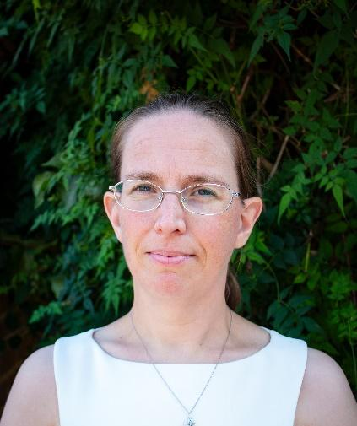

The Deputy Designated Safeguarding Leads (DDSL) are:

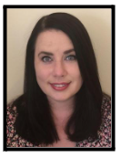
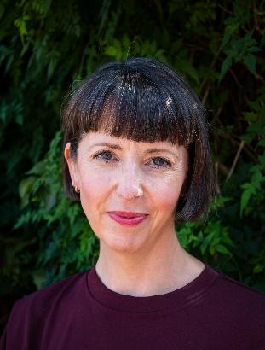

Mrs Sukonik
Assistant Principal
(Last training completed
10th October 2024)
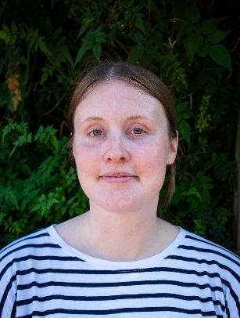
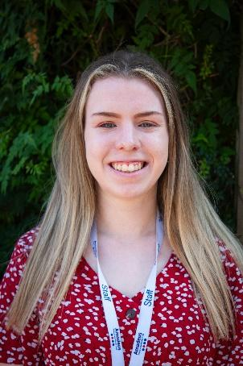

Miss Hobin-Brady
SENCO
(Last training completed
23rd September 2022)

Mrs Cusselle
Class Teacher / Phase Leader
(Last training completed
23rd April 2024)
Miss Childs
Class Teacher /Phase leader
(Last training completed
23rd April 2024)

